**Question:** How do we turn a layout of a room into a graph?

*By Jelle Schroijen*

**Sub questions:**

1. What do several objects in a room represent in a graph?
   * What object should represent the root2 of a graph?
   * What objects should represent the leaves3 of a graph?
2. How do we determine the weight of an edge1?

1: An edge/vertice is a connection between 2 nodes.

2: The root is the first node in a graph. Note that for this to work, a graph must be of a tree type, which is a special subgroup of graphs.

3: The leaves are the endpoints of a graph. This means that they will only connect to one edge.

**We will try to get the answers to these questions using some examples.**

Example 1:

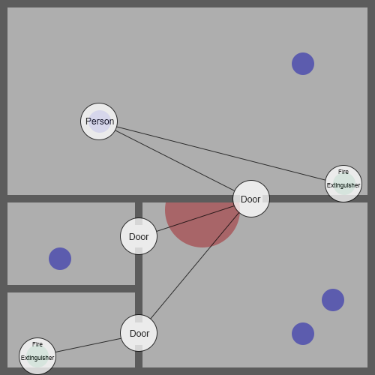

Description

We have a 50 by 50 units room. The walls are all 1 unit thick. The doorways in the walls are 3 units wide. There are walls all along the outside perimeter. The room has been divided up into 2 rooms, of which, one room has been divided up into 3 rooms. There are 5 people in the room, represented as blue dots, and there are 2 fire extinguishers in the room, represented as green dots. There is one fire in the room, represented by the colour red.

Conclusion from example 1

In this case the root of the graph is one of the people. This means that if you want to calculate the paths for all the people in the room, you need to generate a graph for every single person. The weight of the edges is determined by the distance from one node to the other. You can see that two of the edges are going right through the fire, to make sure this person doesn’t use this path, you could increase the weight of these edges so the person would instead use a different path.

In this example we put nodes at the doors, we do not however see any corners that the person might run into if they follow a straight path. We will look further into this in another example.

So far, we can see that for **sub question a**, we have people representing roots, fire extinguishers representing leaves, and doors representing nodes. We can also see that for **sub question b**, we use the distance between the two connected nodes, and look if the edge goes through fire.